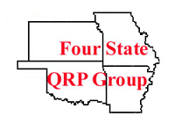

K5EST- 2008


This is

ur call here

An Amateur Radio Station
operating with the

Four State QRP Group

FSQG encourages Amateur Radio Operators, licensed by the Federal Communications Commission (FCC), to get out to the outdoors and operate portable radio stations. This enhances the communications skills of the operator and enhances the Emergency Communications preparedness of the operator and radio equipment. The FCC also allows Amateur Radio Operators to design, build, and operate equipment that is built at home, ie Homebrew, or they may choose to operate an Amateur Radio station that is commercially available to licensed Amateur Radio Operators.

